Nolan Anderson

Prelab 11 and 12

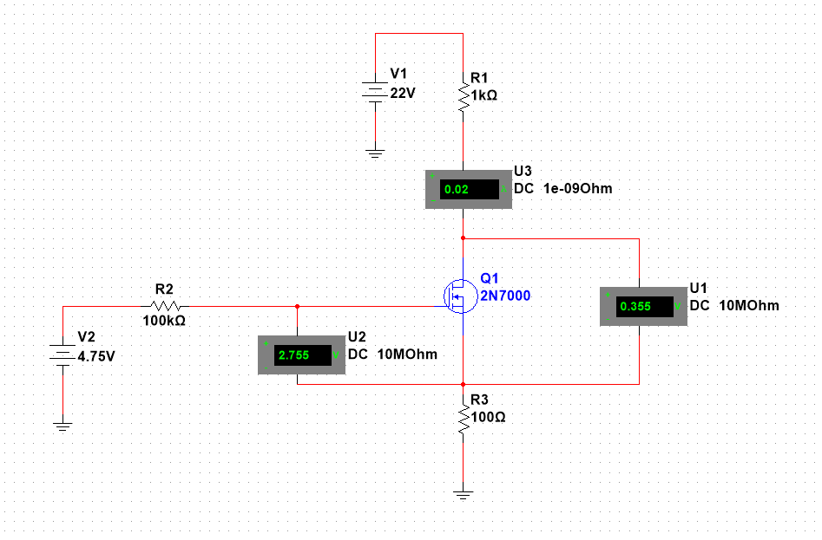

Figure 11.1: Lab 11 Circuit

|  |  |  |  |  |  |  |  |  |  |  |  |
| --- | --- | --- | --- | --- | --- | --- | --- | --- | --- | --- | --- |
| V2 = 2.5 V | V2 = 2.5 V | V2 = 2.5 V | V2 = 3 V | V2 = 3 V | V2 = 3 V | V2 = 3.5 V | V2 = 3.5 V | V2 = 3.5 V | V2 = 4 V | V2 = 4 V | V2 = 4 V |
| Vds (mV) | Vgs (V) | Id (mA) | Vds (mV) | Vgs (V) | Id (mA) | Vds (mV) | Vgs (V) | Id (mA) | Vds (mV) | Vgs (V) | Id (mA) |
| 0.000487 | 2.475 | -0.000022 | -0.00031 | 2.97 | -0.000027 | -0.00025 | 3.465 | -0.000031 | -0.00022 | 3.96 | -0.000036 |
| 11 | 2.431 | 0.445 | 11 | 2.881 | 0.889 | 16 | 3.287 | 1.803 | 19 | 3.692 | 2.71 |
| 24 | 2.387 | 0.887 | 25 | 2.793 | 1.795 | 37 | 3.109 | 3.603 | 45 | 3.424 | 5.414 |
| 42 | 2.344 | 1.325 | 42 | 2.704 | 2.689 | 66 | 2.931 | 5.395 | 82 | 3.158 | 8.108 |
| 67 | 2.301 | 1.757 | 65 | 2.616 | 3.577 | 110 | 2.755 | 7.173 | 142 | 2.893 | 11 |
| 107 | 2.26 | 2.176 | 97 | 2.529 | 4.457 | 190 | 2.582 | 8.918 | 173 | 2.806 | 12 |
| 215 | 2.25 | 2.532 | 148 | 2.444 | 5.32 | 732 | 2.451 | 10 | 216 | 2.72 | 13 |
| 712 | 2.24 | 2.534 | 266 | 2.364 | 6.121 | 2731 | 2.451 | 10 | 280 | 2.635 | 13 |
| 1212 | 2.224 | 2.534 | 632 | 2.352 | 6.243 | 4731 | 2.451 | 10 | 405 | 2.557 | 14 |

Table 11.1: VDs, VGs, Id of Figure 11.1

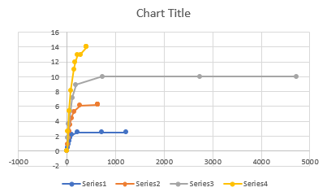

Figure 11.2: Table 11.1 graphed

|  |  |  |
| --- | --- | --- |
| V2  (V) | Vgs (V) | Id (mA) |
| 0 | -0.217 | 0 |
| 2 | 1.98 | 0 |
| 2.25 | 2.136 | 0.927 |
| 2.5 | 2.224 | 2.533 |
| 2.75 | 2.293 | 4.334 |
| 3 | 2.352 | 6.242 |
| 3.25 | 2.404 | 8.219 |
| 3.5 | 2.451 | 10 |
| 3.75 | 2.494 | 12 |
| 4 | 2.535 | 14 |
| 4.25 | 2.573 | 17 |
| 4.5 | 2.609 | 19 |
| 4.75 | 2.755 | 20 |

Table 11.2: Vgs vs Id

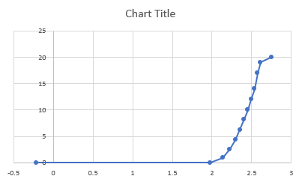

Figure 11.2: Table 11.2 graphed

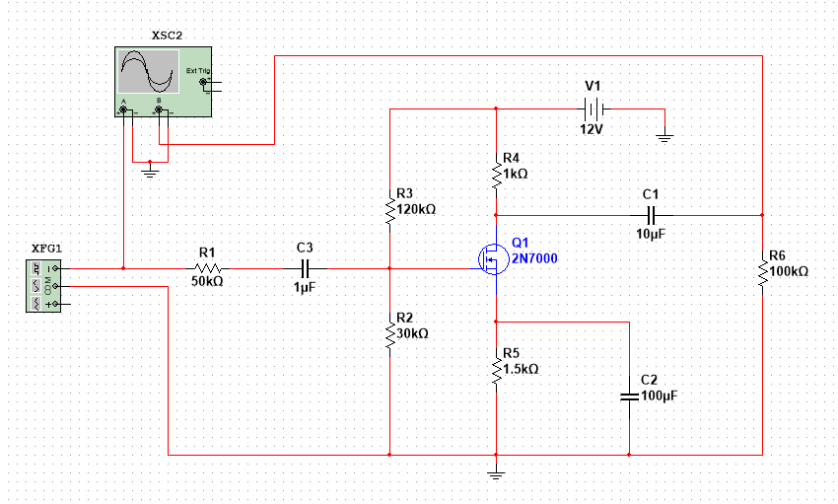

Figure 12.1 Lab 12 Circuit

|  |  |  |
| --- | --- | --- |
| Frequency | Vout (mV) | Voltage Gain |
| 10 | 328 | 4.296876961 |
| 30 | 589 | 9.381705982 |
| 60 | 657 | 10.33070748 |
| 100 | 677 | 10.59117346 |
| 200 | 685 | 10.69321152 |
| 500 | 688 | 10.73116885 |
| 1 KHz | 687 | 10.71853483 |
| 2 KHz | 688 | 10.73116885 |
| 5 KHz | 688 | 10.73116885 |
| 10 KHz | 684 | 10.68052212 |
| 15 KHz | 683 | 10.66781416 |
| 20 KHz | 678 | 10.60399396 |
| 50 KHz | 639 | 10.08941725 |
| 75 KHz | 595 | 9.469739401 |
| 100 KHz | 546 | 8.723252941 |
| 150 KHz | 453 | 7.101364127 |
| 200 KHz | 378 | 5.529236083 |
| 500 KHz | 175 | -1.15983894 |
| 750 KHz | 119 | -4.509660685 |
| 1 MHz | 89.6 | -6.97443972 |
| 2.0 MHz | 45.1 | -12.93706908 |
| 3.0 MHz | 30 | -16.47817482 |

Table 12.1: Vout, gain, and frequency

Figure 12.2: Gain vs Frequency